 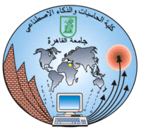

**Faculty Of Computers and Artificial Intelligence**

**Cairo University**

**212202.FCI.AI496.Selected Topics in Artificial intelligence-2**

**Assignment (2)**

**AYA SABRY MOHAMED**

**2018035**

**Submitted to**

**Eng.Salah Mostafa**

**May 2022**

# **Colab links**

# **MC Area Calculation**

<https://colab.research.google.com/drive/1atcjbzbdk58REi461at_6IkQfRu8_BC4?usp=sharing>

**(finished with jupyter code and pdf)**

# **MC Estimations 2: State machine state probability**

<https://colab.research.google.com/drive/1DfjJTodomm59rfqvJRbbLXLefwzftHUT?usp=sharing>

**(I’m still working on it)**